Internal Assessment Resource
Science Level 1
EXPIRED
This resource supports assessment against:
Achievement Standard 90942 version 3
Investigate implications of wave behaviour for everyday life
Resource title: Now You See it, Now You Don’t
4 credits
This resource:
- Clarifies the requirements of the standard
- Supports good assessment practice
- Should be subjected to the school’s usual assessment quality assurance process
- Should be modified to make the context relevant to students in their school environment and ensure that submitted evidence is authentic

Date version published by Ministry of Education | February 2015 Version 3  To support internal assessment from 2015
Quality assurance status | These materials have been quality assured by NZQA.  NZQA Approved number A-A-02-2015-90942-02-4591
Authenticity of evidence | Teachers must manage authenticity for any assessment from a public source, because students may have access to the assessment schedule or student exemplar material.  Using this assessment resource without modification may mean that students’ work is not authentic. The teacher may need to change figures, measurements or data sources or set a different context or topic to be investigated or a different text to read or perform.

Internal Assessment Resource
Achievement Standard Science 90942: Investigate implications of wave behaviour for everyday life
Resource reference: Science 1.3A v3
Resource title: Now You See It, Now You Don’t
Credits: 4
Teacher guidelines
The following guidelines are designed to ensure that teachers can carry out valid and consistent assessment using this internal assessment resource.
Teachers need to be very familiar with the outcome being assessed by Achievement Standard Science 90942. The achievement criteria and the explanatory notes contain information, definitions, and requirements that are crucial when interpreting the standard and assessing students against it.
Context/setting
This standard requires students to show awareness of an aspect of wave behaviour that has an impact on everyday life. The context for this assessment is a report explaining how mirages are created on roads.
Students will carry out a practical experiment, carry out further research, process the information gathered, form a conclusion, and present a report.
In the practical experiment, students will discover that a refractive optical medium, e.g. a glass block or a layer of hot air, can reflect an image to form a mirage.
The findings in their report will need to link their prior knowledge, the information gathered on mirages, scientific theory of waves, and their experimental data.
Students will need prior knowledge of the reflection of light at a plane surface, and the refraction of light at a straight boundary between two materials of different refractive index.
Conditions
This assessment activity requires approximately three hours.
Students will work in groups of no more than three to carry out experiments and gather information/data about the creation of mirages.
Students will work independently to write their reports.
Resource requirements
Provide each group with a power pack, a ray box with a single slit, and a glass block or other appropriate optical medium, e.g. a beaker of water.
An example planning template is provided in Teacher Resource A. Use or adapt it as appropriate to your students and context.

Additional information
Information for students about refraction, waves, and mirages is available at:
- http://mintaka.sdsu.edu/GF/mirages/mirintro.html
- http://library.thinkquest.org/15433/
- http://www.ewart.org.uk/science/waves/wav5.htm

Teacher Resource A: Planning template
Use or adapt this template to suit your context, as appropriate.
Put your question here.
You may need to break the question into smaller questions. Use a new page for each additional question.
Research question:

Source | Information | Key words | In your own words
 | Record information from sources here.  Include only what you need. |  | Take your key words and make new sentences. Use them to help answer your question.
Put reference details here (URLs, texts, articles, etc). | List the key words in this column.  Use individual words, not sentences.  There may be many key words.
Summary:
Summarise your new sentences here. Your summary should answer your question.
If your planning template is more than one page, write your summary on the last page.

Internal Assessment Resource
Achievement Standard Science 90942: Investigate implications of wave behaviour for everyday life
Resource reference: Science 1.3A v3
Resource title: Now You See It, Now You Don’t
Credits: 4
Achievement | Achievement with Merit | Achievement with Excellence
Investigate implications of wave behaviour for everyday life. | Investigate, in- depth, implications of wave behaviour for everyday life. | Investigate, comprehensively, implications of wave behaviour for everyday life.
Student instructions
Introduction
You can often see a mirage on hot, cloudless days. An optical illusion of a sheet of water appears on the road or ground ahead. In this photo, the field is completely dry.
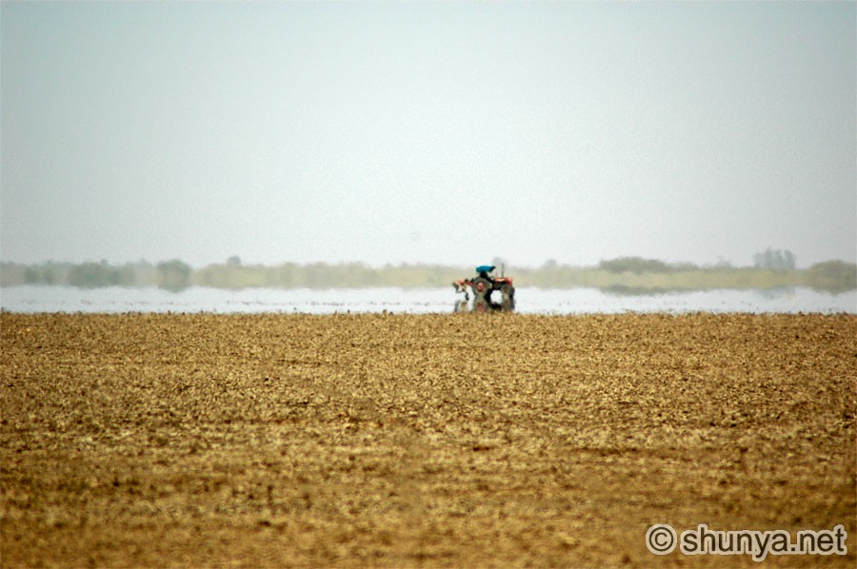
Photo courtesy of Shunya.net http://www.shunya.net
This assessment task requires you to find out and explain how a mirage is created.
You will gather data in experiments you conduct in groups of up to three students.
Working independently, you will use your experimental results to prepare a report that describes your findings and explains the impact this aspect of wave behaviour has on everyday life.
Teacher note: Specify in-class and/or out-of-class time, a time frame, and a due date, e.g. “You have one week of class time to complete this work. Your due date is…”
You will be assessed on how well you are able to research the creation of mirages and draw conclusions linked to physics theory about this aspect of wave behaviour and its implications for everyday life.
Task
See Student Resource A for further guidance.
Gather primary data
Your teacher will supply you with a power pack, a ray box with a single slit, and an optical medium, such as a glass block.
In a group of up to three students, set up and carry out an experiment that models light travelling at different directions through the atmosphere.
Make sure each member of your group agrees on and records the same data.
Gather secondary data
Collect relevant information on how mirages are created, from a range of sources.
Teacher note: You could provide or adapt the planning template in Teacher Resource A.
Collect enough information to allow you to discuss the links between waves, scientific theory, and the results of your experiment.
Prepare a report
Write a report that explains the implications of the wave behaviour of light for everyday life by:
- explaining why on hot, sunny days, the road ahead might appear to be wet
- linking the data you have gathered to scientific theory, e.g. providing scientific reasons why certain conditions (and not others) create a mirage
- describing the impact of this aspect of wave behaviour on your life.
Use scientific statements, show calculations, and state units, as appropriate, in your report.
Include your data with your report.
Student Resource A: Further guidance
Gathering data
In your experiment, you will need to direct waves of light towards and inside your optical medium until one of the surfaces (either an inside surface or an outside surface) completely reflects the light, so that it acts like a mirror instead of refracting.
Your data should allow you to determine:
- how a light wave changes as it moves through different mediums
- what directions light waves are travelling in, at selected points inside the medium
- what conditions are likely to produce a reflection
- what conditions are unlikely to produce a reflection.
Record your data in an organised way. For example, you could draw diagrams showing different configurations of your apparatus, and the corresponding results.

Assessment schedule: Science 90942 Now You See It, Now You Don’t
Evidence/Judgements for Achievement | Evidence/Judgements for Achievement with Merit | Evidence/Judgements for Achievement with Excellence
The student investigates implications of wave behaviour for everyday life.  The student gathers and processes data and prepares a report that shows awareness of how science is involved in the formation of a mirage.  In their report, the student describes how waves refract, includes a diagram or narrative description of experimental results, and describes link(s) between the theory of refraction and the appearance of a mirage.  For example (partial; information about, and discussion of most of):  When light travels from a substance with high refractive index towards a substance with low refractive index it can be reflected at the boundary.  On hot, sunny days the air above a road surface is hot but gets cooler as the distance from the surface increases.  Hot air has a lower refractive index than cool air.  Light from the sky is reflected (angle of incidence above the critical angle) by the hot air at the surface of the road.  If the reflected light from the sky goes into your eye you “see” what appears to be water. | The student investigates, in-depth, implications of wave behaviour for everyday life.  The student gathers and processes data and prepares a report that provides reasons for the way science is involved in the formation of a mirage.  In their report, the student explains how waves refract, includes a diagram or narrative description of experimental results, and explains the link(s) between the theory of refraction and the appearance of a mirage.  For example (partial; information about, and discussion of several of):  When light travels from a substance with high refractive index towards a substance with low refractive index it is reflected at the boundary if the angle of incidence is high enough.  When light from the sky hits the heated air above the road it is going into lower refractive index air.  The angle at which the light from the sky hits the heated layer of air has to be large enough for the light to be reflected. | The student investigates, comprehensively, implications of wave behaviour for everyday life.  The student gathers and processes data and prepares a report that provides reasons and links these together to clearly explain the way science is involved in the formation of a mirage.  In their report, the student explains in-depth how waves refract, includes a detailed diagram or narrative description of experimental results, and explains the key link(s) between the theory of refraction and the appearance of a mirage.  For example (partial):  When light from the sky hits the heated air above the road it is going into air which is getting hotter and hotter and so it is going into air whose refractive index is getting lower and lower.  If the light that starts to go into hotter air has too small an angle to be reflected it will be bent away from the normal. This will increase the angle of incidence of the light going into the even hotter air – eventually the angle of incidence will be big enough for the light to be reflected into your eye.  Because there will be a range of angles of incidence that will give the right reflection the patch of “water” will extend over some distance along the road.
Final grades will be decided using professional judgement based on a holistic examination of the evidence provided against the criteria in the Achievement Standard.

